Lab Assignment: Lab 1 – Data Visualization, Data Preprocessing, and Statistical Analysis Using Python in Jupyter Notebook on Weather Data
RAGHAV ADV BIG DATA ASSIGNMENT
University of the Cumberlands

Introduction
This lab will cover a full hour of weather data from Kaggle, which includes 8784 records for an hourly time period and variables including temperature, dew point temperature, relative humidity, wind speed, visibility, pressure and weather conditions, for a location in Canada (2012 data). The goal was to use some of the principles of data science: loading and examining the data, making meaningful visualisations, pre-processing (fill-in missing values, outlier detection, data reduction, scaling, and discretization) and performing statistical analysis to extract insights into weather patterns. The results show high interdependencies between meteorological variables and provide examples of data preparation procedures (Molin, S. 2021).
Step 1: Data Collection
Successfully loaded the data into Pandas Dataframe from the Kaggle source. January 1, 2012, is the start date of a clean hourly timestamped structure (the first 5 rows). The columns contain a categorical description of the weather, numeric meteorological measures, and Date/Time (datetime). There were no immediate problems with loading and the datetime conversion allowed for the potential analysis of time-series.
Step 2: Data Visualization
There are two main visualizations created to explore relationships and distributions.
Temperature vs. relative humidity (colored by wind speed) graph.
The scatter plot displays a large number of points with a moderate negative correlation between temperature and relative humidity. The increase in humidity (>80%) is more concentrated towards the lower temperatures, particularly below 10°C; the higher temperatures have a wider, but typically lower, humidity range. The colour gradient (viridis) for wind speed shows that a higher wind speed can be observed to occur under many different conditions, but can be seen to be a little more intense in certain mid-range clusters. A small lesson in meteorology: in the winter, there will be less moisture capacity in the air, which means higher relative humidity. The graph also shows that the data is skewed toward the warmer temperatures (0-20°C) and higher humidity (60-90%) that are common in the region.
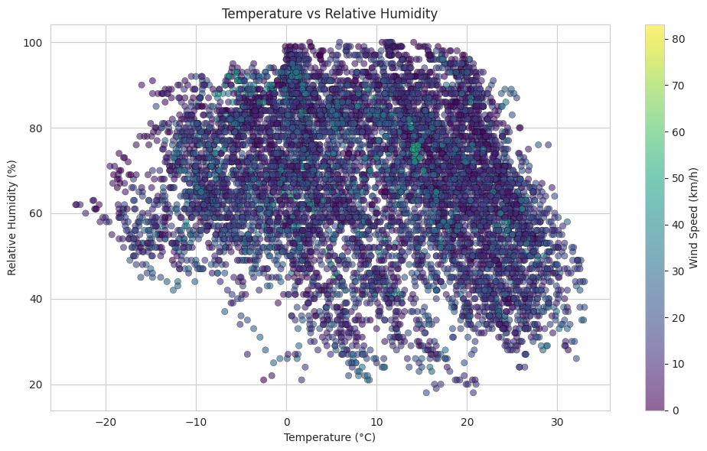
Box Plot: Distribution of temperatures in the top 8 weather conditions
The box plot is used to compare the temperature ranges of different weather types. Based on the median and the narrow spread (mostly below zero), the lowest is associated with snow and that is confirmed by the data. The median values of “Fog” and “Mostly Cloudy” are lower than the median values of “Mainly Clear” and “Clear”, respectively, which have the widest ranges and the highest upper whiskers, suggesting that clear skies occur across seasons. The medians of “Rain” and “Rain showers” are moderate, positive values. There are a number of outliers in each category, indicating some sporadic extreme events. This visualization is designed to effectively show how the categories of weather relate to temperature regimes, which can help to develop a pattern for predicting or categorizing weather.
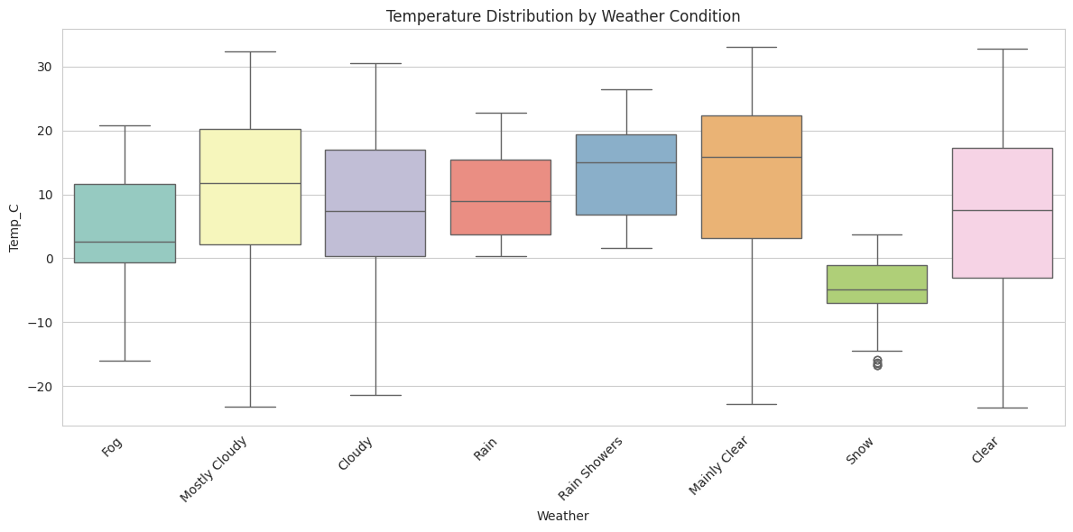
Step 3: Data Preprocessing
3.1 Handling Missing Values
There were no missing values in any column (checked using the function `isnull().sum()`). It is good for analysis but is not typical of real data. To complete the code, the numeric columns were imputed with the median value and the categorical columns were imputed with the mode value, but no changes were necessary. The data-set was not corrupted.

3.2 Outlier Detection and Removal.Outlier Detection and Removal 3.2.
Outlier detection for variable `Visibility_km` by using the method IQR. With Q1 = 24.1 km, Q3 = 25.0 km, and IQR = 0.9 km, bounds were set at approximately 22.75–26.35 km. This resulted in the identification of 3,539 outliers (40.3% of data) the majority of which were low-visibility events during fog, mist or precipitation and were therefore considered meteorologically relevant as opposed to erroneous.

The impact is dramatic, as boxplots before and after removal show: before removal the lower tail was long, with many points below 10 km (as far down as 0.2 km); after removal the plot was very compact around 25 km. After cleaning there were 5245 rows remaining. This step emphasizes the need for domain knowledge; the removal of these “outliers” could be appropriate for clear-weather modelling but not for holistic weather studies where low visibility is critical information.
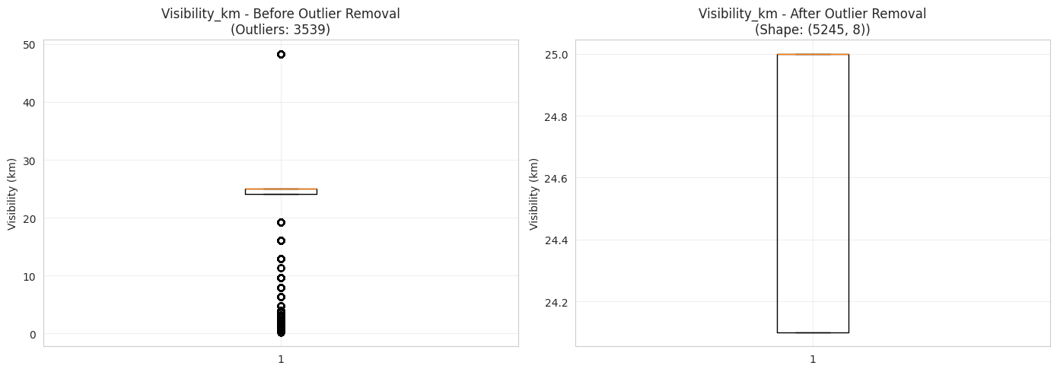
3.3 Data Reduction
For efficiency 30% of the records were selected as a random sample (2635 rows). Also less important columns were removed (Date/Time, Dew Point Temp_C, Press_kPa) leaving only a five core columns DataFrame. This reduction to simple analysis is effected by retaining the full original data-set for other purposes.

3.4 Scaling and Discretization
- Min-Max Scaling: Scaled numeric features to a range between 0 and 1 (useful for algorithms that are sensitive to scale such as neural networks, distance-based methods, etc.).
- Z-score Standardization: Z-Score ≈ 0, Z-Score std ≈ 1 (good for many statistical/machine learning models).
- Discretization: The temperature was discretized into meaningful categories: ‘Very Cold’ < -10°C, ‘Cold’, ‘Cool’, ‘Mild’, ‘Warm’, ‘Hot’. “Mild” and “Cool” are the dominant (~54% combined) followed by 0.77% of “Hot” days, indicating a temperate climate. This transformation helps to improve interpretability and rule-based analysis.

Step 4: Statistical Analysis
4.1 General Overview
The data set has 8784 observations per hour for 1 year. A table with a summary of the statistics (`describe()`) is provided to display:
- Temperature ranges from -23.3°C to 33.0°C (mean 8.80°C, median 9.3°C).
Average visibility is 27.66 km, but with high variability.
Pressure is fairly consistent (mean 101.05 kPa).

4.2 Central Tendency
For most variables means and medians are similar, which suggests near symmetrical distributions (except visibility, which is skewed by low values). Modes give the conditions that are known to occur often (such as humidity mode = 68%, wind speed mode = 9 km/h).

4.3 Dispersion Measures
The spatial and temporal variations of temperature and dew point are high, as expected for seasonal data (std ~11–12°C, CV >100%). Moderate dispersion of Humidity and Wind Speed. The range is large, as the outlier/low group has a high standard deviation. The most stable (CV 0.84%) is pressure. These measures measure the dynamism of this dataset over seasons.

4.4 Correlation Analysis
The heatmap and correlation matrix display strong patterns:
- The relationship between `Dew Point Temp_C` and `Temp_C` is very strong positive correlation (0.93) – this is expected as the Dew Point is related to the actual moisture content associated with the Temperature.
- Negative correlation between `Rel Hum_%` and `Visibility_km` of (-0.63) — high humidity can often be associated with fog or rainfall, which may result in poor visibility.
- There is a negative correlation between temperature and humidity with the overall value of -0.22.
- Weak or near-zero correlations for wind speed with most variables.
These findings validate the physical relationships in meteorology and can inform feature selection for predictive modelling.
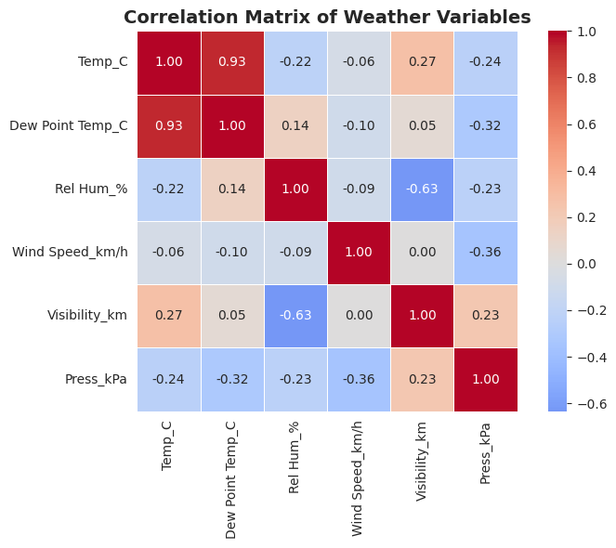
Key Insights and Challenges
It points to a typical temperate climate with distinct seasonal variations, cold winters, wet, hazy weather, and warm summers, clear weather. Visualisations worked well to reveal bivariate relationships, and pre-processing revealed the trade-off between statistical “cleaning” and domain relevance (particularly with regard to the visibility outliers). There was a good quantitative basis as provided by statistical measures.
Some difficulties were encountered, such as the treatment of outliers for visibility (which was the domain context that remained in the report) and the high cardinality of the `Weather' column, which meant that the top categories needed to be focused on for visualization. The iterative exploration was efficient with the Jupyter Notebook workflow (Shen, S. S., 2023).

References
Shen, S. S., Shen, S. S., & North, G. R. (2023). Statistics and Data Visualization in Climate Science with R and Python. Cambridge University Press.
Molin, S. (2021). Hands-On Data Analysis with Pandas: A Python data science handbook for data collection, wrangling, analysis, and visualization. Packt Publishing Ltd.

